YEAR 11 GENERAL HUMAN BIOLOGY

DO NOT MARK THIS BOOKLET

Multiple Choice 15 Marks
Short Answer 25 Marks
Total 40 Marks
Pregnancy and Birth Test
Part 1: Multiple Choice (15 marks)

1. Which hormone is responsible for the production of breast milk?

- Progesterone.
- Prolactin.
- Oxytocin.
- Oestrogen.

2. Which hormone inhibits milk expression before birth?

- Progesterone.
- Prolactin.
- Oxytocin.
- Oestrogen.

3. Which hormone surges after birth, often helping the mother bond with the baby?

- Progesterone.
- Prolactin.
- Oxytocin.
- Oestrogen.

4. What is NOT a reason for inducing labour?

- High blood pressure.
- Bleeding.
- A pregnancy that has gone longer than 42 weeks.
- Breech presentation.

5. The third stage of birth includes:

- the placenta, amnion and chorion being expelled.
- bursting of the amniotic membrane.
- full dilation of the cervix.
- the foetus moving further down into the pelvis.

6. Which of the following are incorrect?

- The placenta filters maternal blood before it is passed to the baby
- The amniotic fluid helps protect the baby from shock
- The baby develops inside the placenta
- Certain small molecules can pass from the maternal bloodstream into the foetal bloodstream e.g. alcohol

7. | What is the purpose of the umbilical cord?
 |  | - It tethers the foetus to the uterine wall so it the foetus isn't born too early
 |  | - It supplies the foetus with oxygen and nutrients and takes waste products away
 |  | - When the umbilical cord is cut after the foeus is born, it becomes the belly button
 |  | - It could wrap around the baby's neck during birth

8. The correct order of events during labour is:

- Placenta detaches, cervix dilates, baby is born
- Baby is born, placenta detaches, cervix dilates
- Cervix dilates, baby is born, placenta detaches
- Cervix dilates, placenta detaches, baby is born

9. The neural tube of the baby is formed during which month?

- 1
- 2
- 3
- 4

10. Which of the following are NOT harmful to the development of the foetus:

- Folic acid
- Thalidomide
- Mercury
- Alcohol

11. An ectopic pregnancy is one in which:

- the embryo or foetus is spontaneously aborted.
- many factors including poor nutrition, hypertension or endocrine imbalances cause swelling of the mother’s feet, face and legs.
- there is increased vaginal discharge due to additional secretions from glands of the cervix.
- the blastocyst implants at a site other than the uterus, possibly rupturing the fallopian tube as the embryo grows.

12. Pregnancy tests measure the levels of which hormone?

- Progesterone
- Human Chorionic Gonadotrophin
- Luteinising hormone
- Estrogen

13. What is the embryo called at implantation?

- Blastocyst
- Morula
- Embryo
- Zygote

14. Which of the following is NOT a sign of early pregnancy?

- Morning sickness.
- Abdominal swelling.
- Absence of menstrual periods.
- Breast swelling and tenderness.

15. Which method of testing for abnormalities involves a blood test?

- Chorionic villus sampling
- Amniocentesis
- Maternal serum screening
- Ultrasound

END OF MULTIPLE CHOICE SECTION

Section 2: Short answer
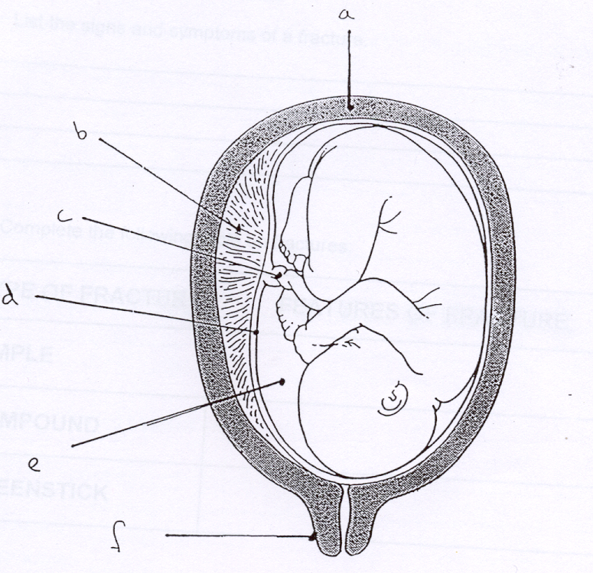

- Complete the labels on the diagram above

A __________________________

B __________________________ E _____________________

C __________________________ F _____________________

(5 marks)

ii) In which period of pregnancy is the infant? (0-3 months, 3-6 months, 6-9 months)

______________________________________________ (1 mark)

  - Give a reasons for your answer (1 mark)

______________________________________________________________

______________________________________________________________

5. Infants are born with a number of reflex movements. Give an example of two reflexes and explain how they aid an infants chance of survival. (4 marks)

1.

2.

List at least two milestones for the foetus and 1 effect felt by the mother at each stage of pregnancy. (9 marks)
 | Foetus | Mother
First trimester
Second trimester
Third trimester

List 3 milestones of infant development in the first 6 months of life. (3 marks )

1.

2.

3.

Describe how ultrasound works (2 marks)

Pregnancy Test Part 2:
SCORES:
MC: /15

SA: /25

TOTAL: /40

_______ %

NAME:_____________________________

TEACHER:__________________________

DATE:______________________________

Section A: Multiple choice (15 Marks)
Answer all questions by circling the most correct answer on the multiple choice answer sheet.

1. a b c d
2. a b c d
3. a b c d
4. a b c d
5. a b c d
6. a b c d
7. a b c d
8. a b c d
9. a b c d
10. a b c d
11. a b c d
12. a b c d
13. a b c d
14. a b c d
15. a b c d

